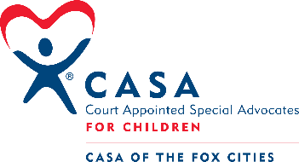
Volunteer Engagement & Training
Report to the Board of Directors
October 2022

- Our final pre-service training session began October 3rd. We have 7 people in this class. At the time of this letter, one participant may need to step away due to recovery from a concussion. I expect that at least one of these participants will not meet our standards for advocacy and therefore will not go on to serve in that capacity. There may be others who do not meet our standard as well.
- This month I completed the Fostering Futures Training of Facilitators as required by National CASA/GAL Association.
- I have assembled a group of advocates to form a Continuing Education Committee. We will meet monthly, with work done between meetings. We are in the process of building a survey with the goal of distributing the survey by 11/4. We will discuss the survey results at our November meeting, then move into planning CE events for the first quarter of 2023.

- Information sessions continue. I see that there is a lag in application turnaround after these sessions. I suspect that may be due to the extent of time before the next training session begins in January.
- There has been some discussion about the number of pre-service training sessions we might run in 2023. There must be consideration given to what it takes to keep a prospective advocate engaged if there is a lapse between their initial interest and the start of training.

- We have secured a spot at this year’s VolunteerFest at Waverly Beach on November 3rd. The event is organized by Volunteer Fox Cities. The goal of this event will be to fill the pipeline for training in January.

- Our annual Holiday Event is scheduled for Monday, December 12th. I am working to secure volunteer groups to assist with this year’s event. At this time, I have a small group from Miller to assist with gift-wrapping and hospitality. I am also looking for a group (hopefully a new corporate group) to assist with the setup for that event. Setup takes place on Friday, December 9th.

Respectfully submitted by Leah Thibodeau on October 20, 2022

