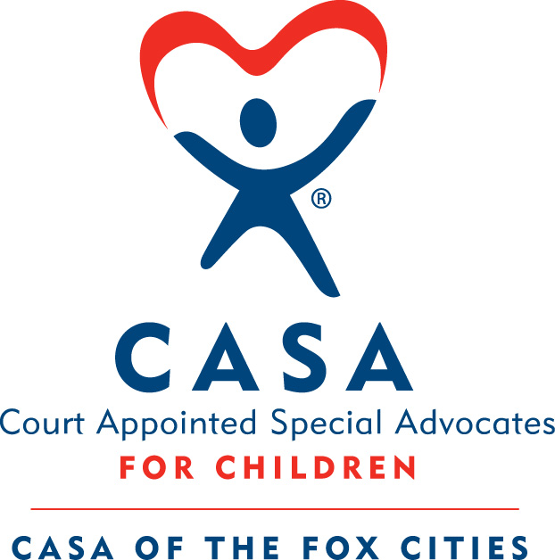

Board of Directors Meeting
Date: November 23, 2021
Location: Abby Bank Lower-Level Conference Room (In-Person)
Attendance:
Directors Present: Kevin Head, Adam Figurin, Chad Ulman, Jim Snyder, Derek Fiestadt, Jason Rottier, Amy Swick, Dennis Bonn, Kathy Drake, Marissa Knuth
Directors Absent: Nora Lazcano, Amy D’Addario
Staff: Dawn Gohlke, Jenn Harper, Selena Trejo, Leah Thibodeau, Whitney Moscinski, Marissa Lee, Kandace Stuyvenberg, Krista Krueger
Guests: Sharon Schumacher (Special Advisor), Jeff Hunter (Strategic Planning Facilitator)
_____________________________________________________________________________________
- Welcome and Introductions (Kevin Head)
  - Introductions of board members and visitors
    - Introductions to staff present for meeting
- Mission Moment (Dawn Gohlke)
  - Dawn presented mission moment.
- Consent Agenda (Kevin Head)
  - October Meeting Minutes
    - Chad moved to accept, Jim seconded, all in favor.
  - October Financials
    - Jim moved to accept, Amy seconded, all in favor.
  - Executive Director Report
  - Supplanting Policy
    - Adam moved to accept, Jim seconded, all in favor.
- Treasurer’s Report (Derek Fiestadt)
  - Kevin’s overall summary
    - YTD we are $54K Favorable to Budget, which the attached file proves. ($117K-$62K)
    - PPP Loan and CASAblanca make up $121K of a favorable revenue variance
    - We are significantly short on Business and Individual Contributions. However Annual Fund also budgeted for November/December.
    - Third Party Events is down and won’t be recovered. We had planned a golf outing but that didn’t happen.
    - Favorable Grants is a good number. We are only about $9K of the annual budgeted grant number.
    - The county/federal ARPA $25K number should be in Other Funding with PPP and was recorded in October.
    - Salaries - Partially this is due to hiring Jenn for Development.
    - November/December - We are budgeted to lose approximately $4K in the last two months. Confident, though, that we will be better than plan based upon some initial Annual Fund numbers.
    - Even if we just follow the budget we should end up positive of $30K for the year. (Budget was originally a loss of $24K).
    - On another note, at the Executive Committee Meeting we discussed approving a new outside accountant. Well, let me tell you a story. When I started this analysis yesterday my first task is always prepare a Statement of Change of Financial Position from month to month. I could not get it to work. Turns out that our outside accountant changed the September financials AFTER she presented then to CASA. She didn’t tell anyone. (Basically she accrued a Grant Receivable so at least the change was favorable. My point is this - We need to vote to change to a new outside accountant.
  - Vote to change outside accountant
    - Too many critical mistakes
      - i.e. In preparing the Statement of Change of Financial Position from month to month for November, we could not get it to work. Turns out that our outside accountant changed the September financials AFTER she presented them to the CASA BOD. She didn’t tell anyone. (Basically she accrued a Grant Receivable so at least the change was favorable.)
    - Will cost us an extra $250/month
    - Name of firm and point person: Theresa Lauer, Hjortness CPA
    - Adam moved to accept, Jim seconded, all in favor.
- Board Recruitment (Kevin Head)
  - Vote on new applications
    - Kathy Drake and Marissa Knuth
      - Adam moved to accept, Dennis seconded, all in favor.
- Organizational Strategy (Jeff Hunter)
  - 2019-2024 Strategic Plan
    - Summary of Process
    - Review of What CASA Does and how this affects Outcomes including pain points that align with Key Strategic Issues
    - Play to Win Canvases
- Upcoming Meeting Dates (Kevin Head)
  - December Meeting and Social
    - Original date December 28, alternate date December 15 (TBD)
  - New Board Member Orientation
- Meeting Adjourned (Kevin Head)
  - Move to Executive Session

