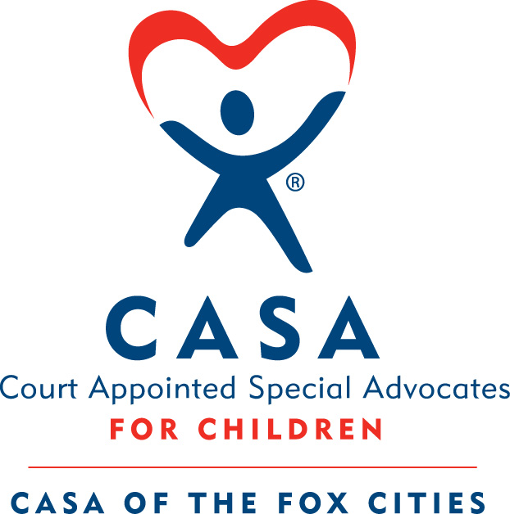

Board of Directors Meeting
Date: October 28, 2021
Location: Abby Bank Lower-Level Conference Room (In-Person)
Attendance:
Directors Present: Kevin Head, Adam Figurin, Chad Ulman, Jim Snyder, Derek Fiestadt, Amy D’Addaria, Jason Rottier
Directors Absent: Amy Swick, Nora Lazcano
Staff: Dawn Gohlke, Jenn Harper
Guests: Sharon Schumacher (Special Advisor), Dennis Bonn, Marissa Knuth, Kathy Drake, Jeff Hunter (Strategic Planning Facilitator)
_____________________________________________________________________________________
- Welcome and Introductions (Kevin Head)
  - Introductions of board members and visitors
- Mission Moment (Dawn Gohlke)
  - Dawn presented mission moment.
    - Shared video of advocate interview with Cory.
- Approval of Minutes (Kevin Head)
  - September minutes were submitted for review.
    - Adam moved to accept, Jim seconded, all in favor.
- Treasurer’s Report (Derek Fiestadt)
  - The September 2021 financials were presented for review
    - Not much for activity.
    - $17k shortfall due to timing of grant receipts
    - $10k over budget on expenses
    - Cash was reported $4000 down from last month
    - Getting proposals for a new accountant
  - Jim moved to accept, Jason seconded, all in favor.
- CASAblanca Report (Jenn Harper)
  - Increase in every area except for sponsorships (compared to 2019)
  - About $80k net exceeds goal
  - Venue was cozy and more space is needed which will raise costs
  - Should be able to sell more tables
  - Looking at alternative dates to avoid competing with other fundraiser events.
  - A lot of positive feedback on band and program.
  - Bill Jartz was awesome.
  - Jenn gave update on 30-60-90 Plan
    - Focus has been on CASAblanca
    - Trying to reach out and re-engage older donors that may have fell off.
    - Update website…talking to Stellar Blue
      - Looking into mini grants to cover costs.
    - Making new connections for support
    - Fund Development needs to re-focus away from CASAblanca now
- Board Recruitment (Kevin Head)
  - Review solicitation list
    - Kathy Drake – finance background, past CHAPS board member, current FVSO board member, husband is a current advocate
    - Marissa Knuth – use to serve with CASA in college thru sorority, Ivy Rose Bridal Boutique owner, event organizer
  - Vote on new applications
    - Dennis Bonn
      - Marketing background
      - Kevin moved to accept, Adam seconded, all in favor.
- Executive Director Report (Dawn Gohlke)
  - Capacity of staff is near capacity.
    - Staff can supervise 7 more advocates (13-18 kids), then a waiting list will have to be created or potentially allow Whitney, Jill or Dawn supervise a case.
    - Some shake-ups in the DA office that may or may not affect referrals; in general, they are going up
  - Dawn reviewed the program metrics (236 currently served YTD)
    - 4 appointments for September 2021
    - 4 closures for September 2021
    - 124 CHIPS cased to-date, which is slightly below last year’s numbers
  - Grants Submitted
    - Wrapping up VOCA submissions and preparing for a 12/10/21 site visit
    - NCASA Mentoring Grant
    - Basic Needs Grant ($35k)
    - Otto Bremer interview ($30k)
    - ARPA response ($25k)
    - Little Rapid Grant ($10k)
  - Grants Received
    - $7,500 from Menasha Corp
    - $5,000 from USV/Schmidt Family Foundation
    - $15,000 from Theda and Tamblin Clark Smith Family Foundation
    - $200 from Investors Community Bank
- Organizational Strategy (Jeff Hunter)
  - 2019-2024 Strategic Plan
    - Managing Strategy with Focus and Agility
      - Creating a rolling plan
      - Engage in a process of learning and development
  - 2021 Market Position Assessment (Dawn Gohlke)
    - See Dawn’s summary in board packet.
    - Think about the 3 goals….are they still relative?....What needs to be tweaked on them based on the events of the past two years?
      - Be prepared to discuss at the next board meeting.
- Meeting Adjourned (Kevin Head)
  - Move to Executive Session

